**E91 Cloud Devops: Fall 2018**

**Assignment 4**

**Stephen Akaeze**

**<https://code.harvard.edu/sta283/cscie-91_sta283>**

**Instruction Manual:** https://canvas.harvard.edu/courses/53026/files/6766783/download?verifier=xUKCvQIgJZRiNwn3UPVakGUKxXvVSFnbP1eWMdZR&wrap=1

**Problem 1**

1. As instructed by the manual, Template 1 (questtemp1.yaml) creates one VPC, subnets and 1 security group permitting ports 80, 443 and 22.

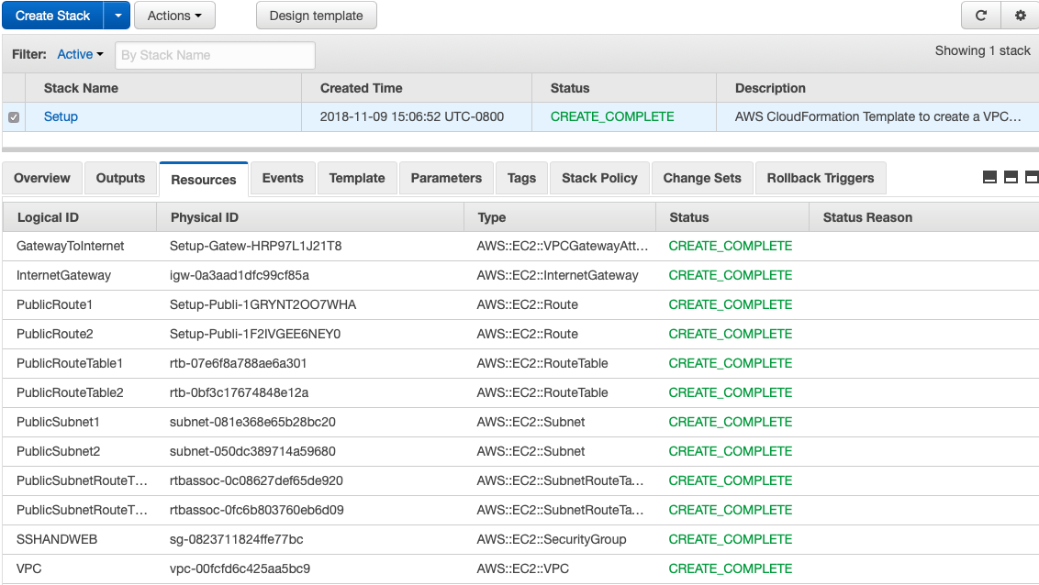

1. Template 2 (questtemp1.yaml) creates 3 instances where the first is located in the first public subnet created from Template 1 while the second and third instances are created in the second public subnet.

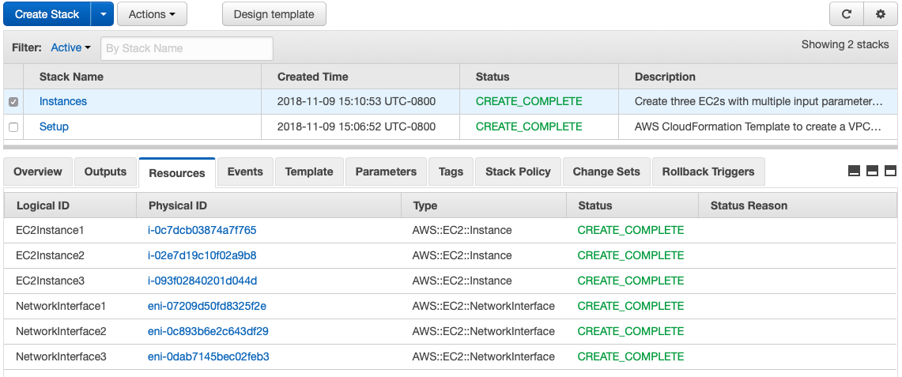

**The GitHub link to both templates is as follows: https://code.harvard.edu/sta283/cscie-91_sta283/tree/master/assignment-04/question-01-templates**

**Problem 2**

1. As instructed by the instruction manual, the VPC, public subnets, private subnets, Load balancer, auto scaling, target groups and launch configuration were created using three different availability zones on us-east-1a, us-east-1b and us-east-1c.
   1. **Network Setup (Template: ques2SubnetSetup.yaml)**

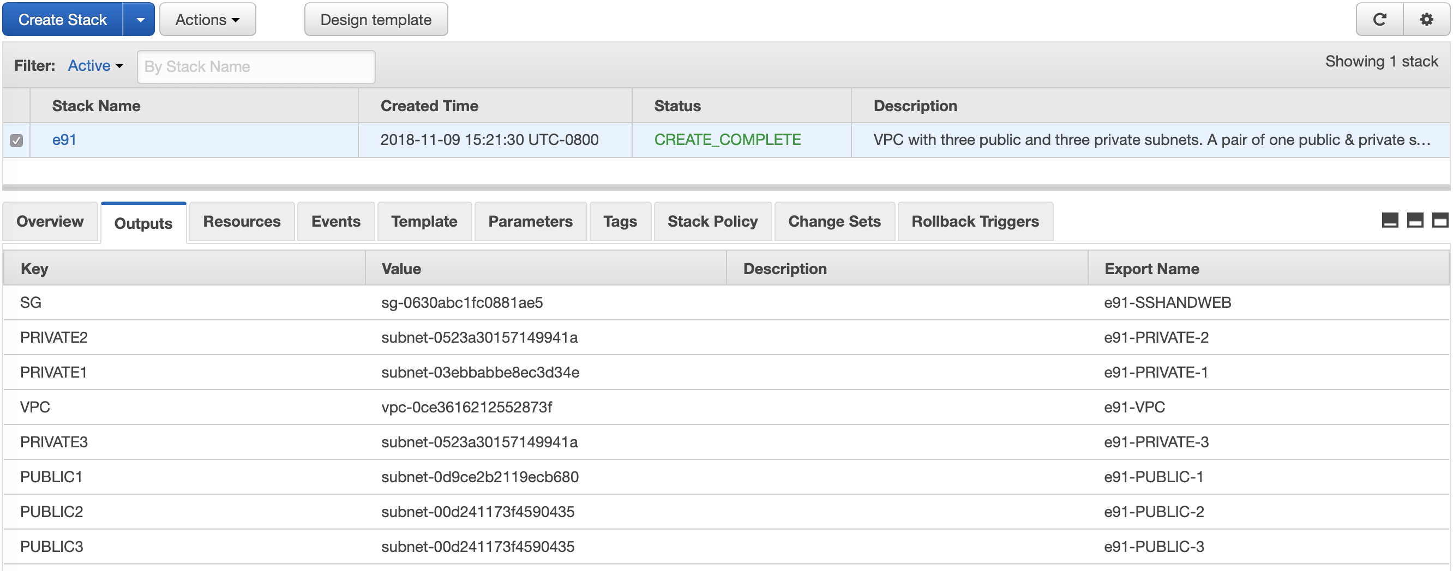

* 1. **Launch Configuration (Template: ques2LaunchConfig.yaml)**

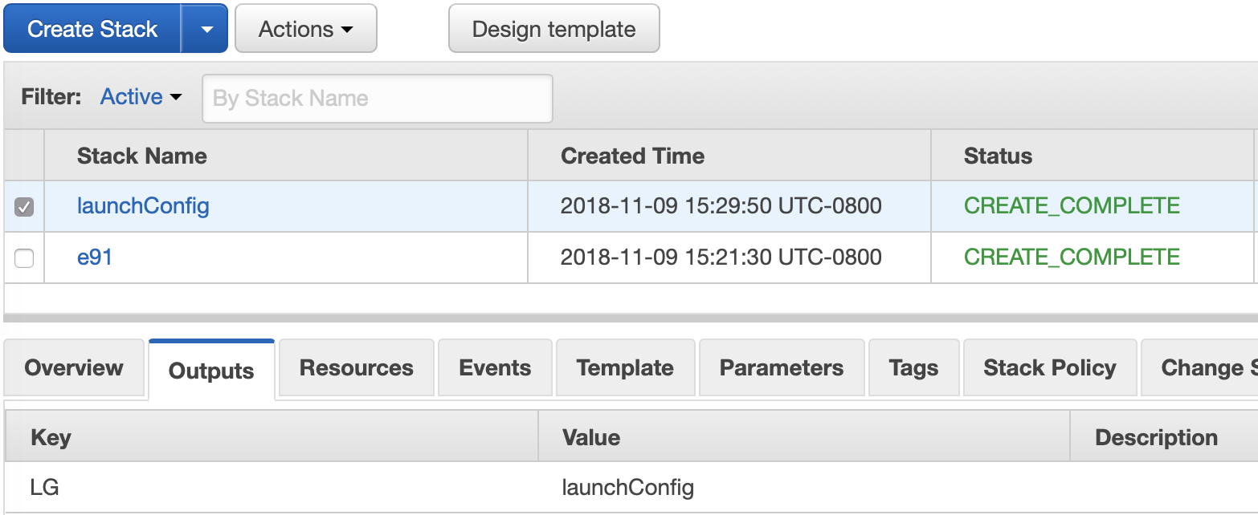

* 1. **Target Group (Template: ques2TargetGroup.yaml)**

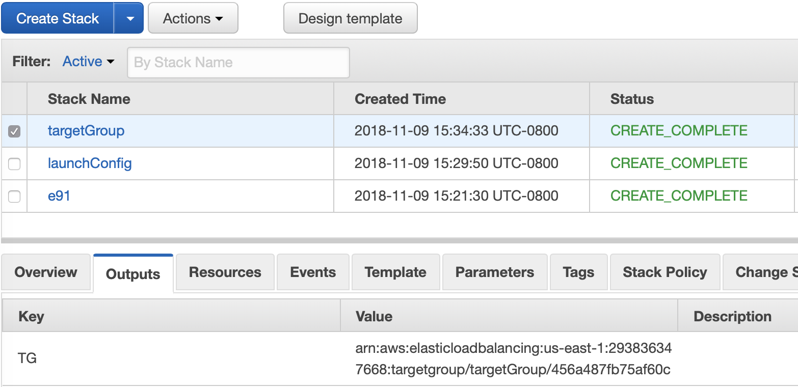

* 1. **Load balancer (Template: ques2LoadBalancer.yaml)**

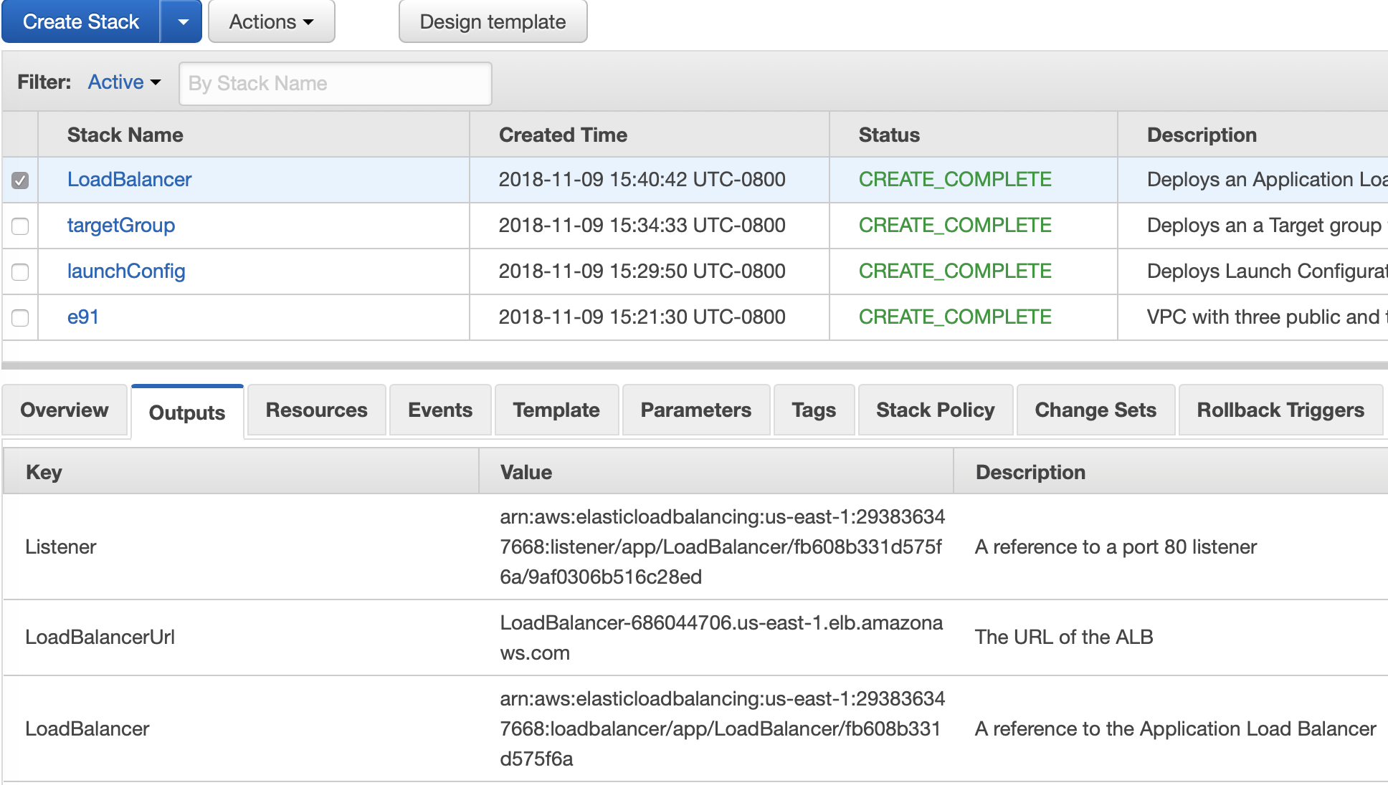

* 1. **Auto Scaling (Template: ques2AutoScaling)**

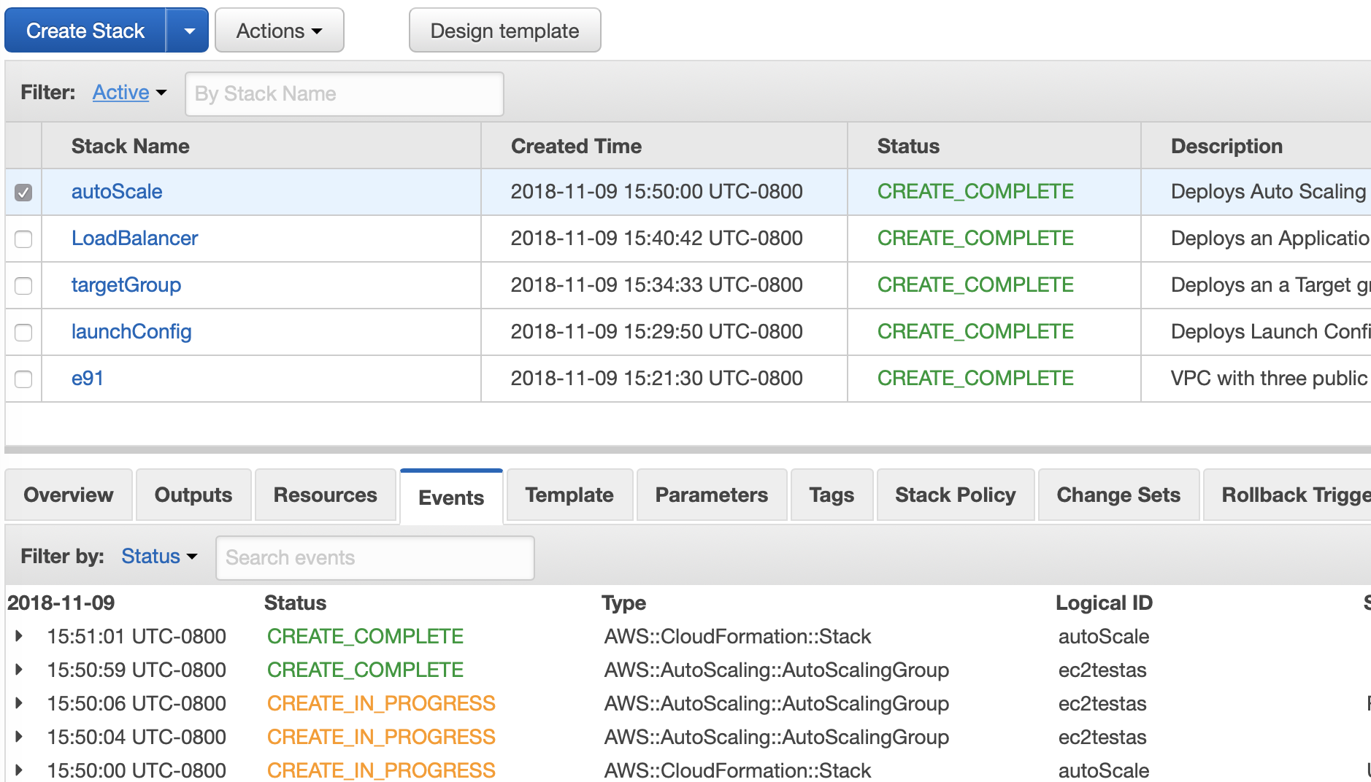

**The GitHub link to the above implemented templates and READ.me file is as follows: https://code.harvard.edu/sta283/cscie-91_sta283/tree/master/assignment-04/question-02-templates-and-READme-response**

**Problem 3**

1. The Ansible server and client were configured as instructed and shown below

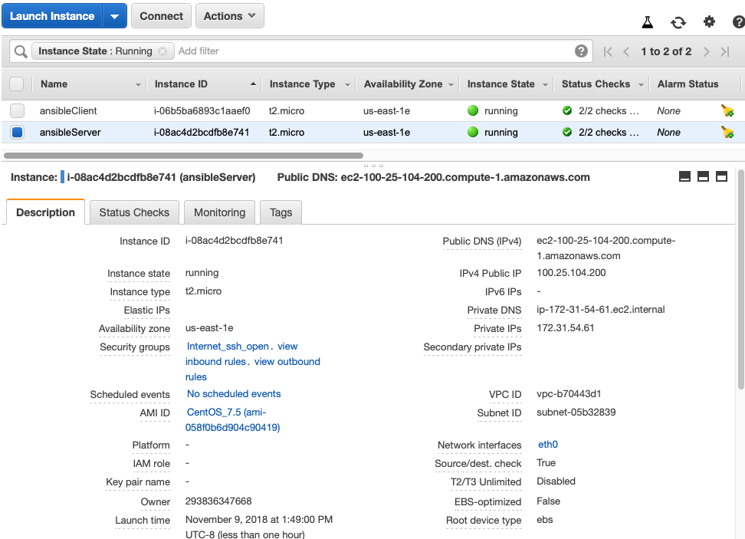

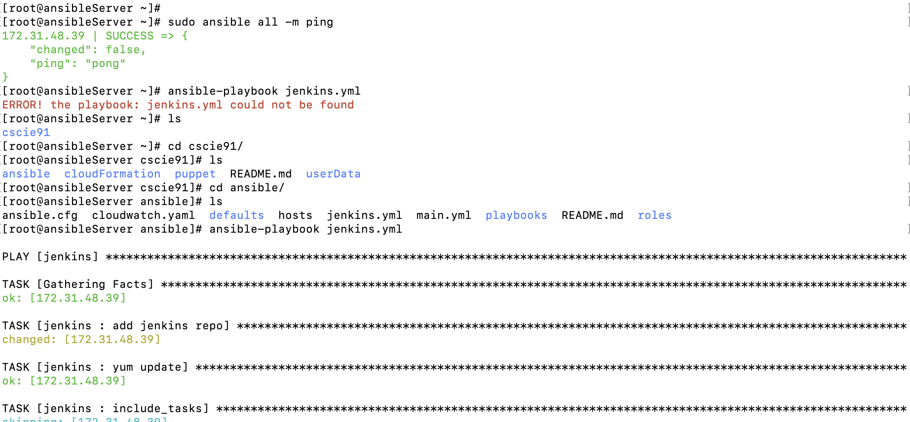

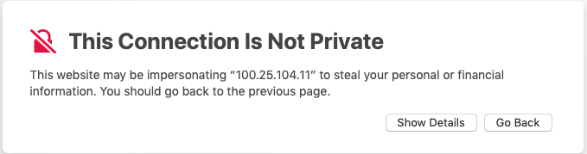

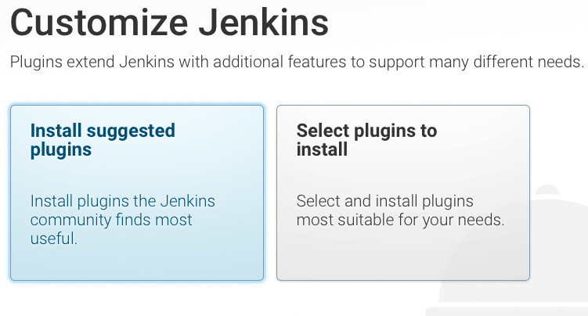

**The GitHub link to the above implemented templates and READ.me file is as follows: https://code.harvard.edu/sta283/cscie-91_sta283/tree/master/assignment-04/question-03-templates-and-READme-response**

**Problem 4**

As instructed by the manual, the templates and Readme file were pushed to dev origin and merged with the master branch.

